1 (a) (i) Define pressure.
………………………………………………………………………………………………………………………………………………………………………………………….. [1]

(ii) State the unit of pressure in base units.
........................................................................................................................................ [1]
(b) The pressure p at a depth h in an incompressible fluid of density ρ is given by
p = ρgh, where g is the acceleration of free fall.
Use base units to check the homogeneity of this equation.
………………………………………………………………………………………………………………………………………………………………………………………………………………………………………………………………………………………… [2]

(c) The percentage errors in measuring the density and depth are 4% and 3% respectively.
Assuming that the acceleration due to gravity is a constant (9.81ms⁻²), find the percentage uncertainty in measuring the pressure.

% uncertainty=………………. [2]

2 The aeroplane shown in Fig 2.1 is travelling horizontally at 95 ms⁻¹. It has to drop a crate of emergency supplies. The air resistance acting on the crate may be neglected.
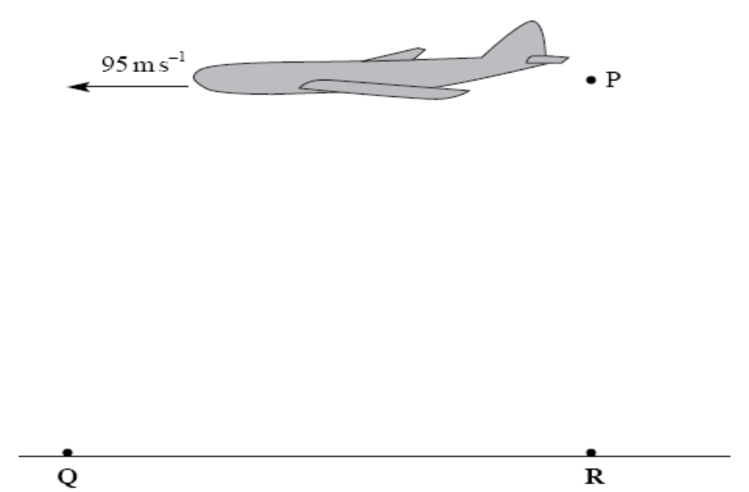

Fig 2.1

(a) (i) The crate is released from the aircraft at point P and lands at point Q. Sketch the path followed by the crate between P and Q as seen from the ground. [1]
(ii) Explain why the horizontal component of the crate’s velocity remains constant while it is moving through the air.
………………………………………………………………………………………………………………………………………………………………………………………………………………………………………………………………………………………….. [2]
(b) (i) To avoid damage to the crate, the maximum vertical component of the crate’s velocity on landing should be 32 ms⁻¹. Show that the maximum height from which the crate can be dropped is approximately 52 m.

[2]

(ii) Calculate the time taken for the crate to reach the ground if the crate is dropped from a height of 52 m.

time =……………s [2]

(iii) If R is a point on the ground directly below P, calculate the horizontal distance QR.

horizontal distance, QR= …………..……m [2]

(c) In practice air resistance is not negligible. State and explain the effect of air resistance on the maximum height from which the crate can be dropped.
……………………………………………………………………………………………………………………………………………………………………………………………………………………………………………………………………………………………………………………………………………………………………………………………..[2]

3 A waiter holds a tray horizontally in one hand between fingers and thumb as shown in Fig 4.1. P, Q and W are the three forces acting on the tray.
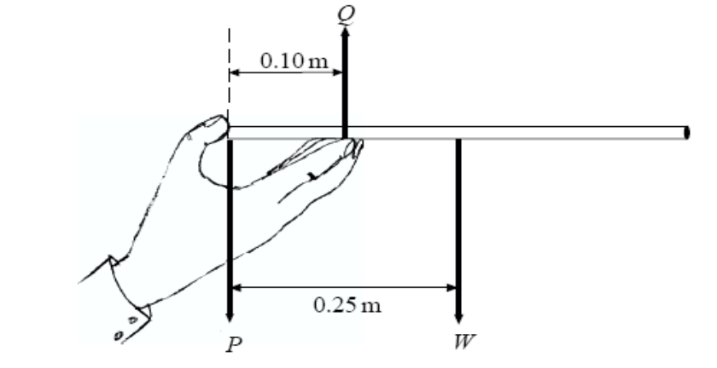

Fig 4.1

(a) (i) State two conditions that must be satisfied if the tray is to remain horizontal and in equilibrium.
………………………………………………………………………………………………………………………………………………………………………………………………………………………………………………………………………………………….. [2]
(ii) If the mass of the tray is 0.12 kg, calculate the magnitudes of forces P and Q.

P =.....………..N
Q = …………..N [3]
(b) The waiter places a glass on the tray. State and explain where the glass should be positioned on the tray if the force, P, is to have the same value as in part (a).
…………………………………………………………………………………………………………………………………………………………………………………………………………………………………………………………………………………………...[2]

4 A skydiver of mass 70 kg, jumps from a stationary balloon and reaches a speed of
45 ms⁻¹ after falling a distance of 150 m.
(a) Calculate the skydiver’s loss of gravitational potential energy,

Potential energy lost =………………….J [2]
(b) Calculate the kinetic energy gained in falling through the distance

Kinetic energy gained = ………………….J [2]
(c) The difference between the loss of gravitational potential energy and the gain in kinetic energy is equal to the work done against air resistance. Use this fact to calculate
the average force due to air resistance acting on the skydiver.

Average force = ………………N [2]
5 Some tensile testing machines operate on specimens of metal shaped like the piece of steel in the diagram below. The specimen is circular in cross-section.
1 mm
20 mm

- The ends of the steel specimen are clamped in the machine, which applies a tensile force. Describe, with the aid of a diagram, how the shape of the specimen will change as the force is increased just before breaking occurs.

……………………………………………………………………………………………………………………………………………………………………………………………………………………………………………………………………………………………………………………………………………………………………………...……………[3]
- For the specimen shown in the diagram above, calculate the following quantities:
(i) The cross-sectional area

Area = …………….…...m² [1]
(ii) The tensile stress in the central section of the specimen when the force is 800 N

Tensile stress= …….………………Pa [2]
(iii) The value of the Young’s Modulus for the steel, given the force of 800 N causes an extension of 0.1 mm.

Young’s modulus= ….………………..Pa [2]

6 Fig 6.1 shows a network of resistors connected to a supply of negligible internal resistance.
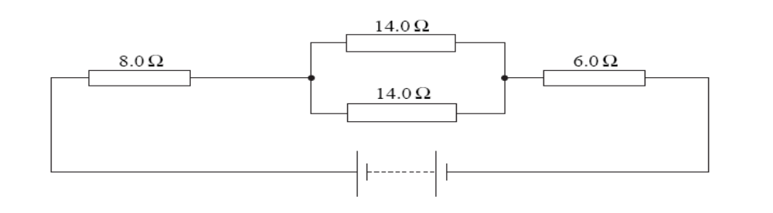
Figure 6.1
(a) Calculate the total resistance of the network of resistors.

Total resistance =...................................Ω [2]

(b) The current in the 8.0Ω resistor is 0.35 A. Calculate
- the current in each of the 14.0Ω resistors,

current =...............................A [1]

(ii) the e.m.f of the supply.

e.m.f =....................................V [2]

7 A diffraction grating has 6.0 × 10⁵ lines per metre. Light from a hydrogen discharge tube is diffracted by the grating.
(a) Calculate the angle of the first order diffraction maximum for light of
wavelength, 6.6 × 10⁻⁷ m.

angle ....................................................[3]

(b) Calculate the highest order that will be visible for light of wavelength 6.6 × 10⁻⁷ m.

highest order ........................................[2]

(c) Describe the difference between longitudinal and transverse waves.
…………………………………………………………………………………………………………………………………………………………………………………………………………………………………………………………………………………………………...………………………………………………………………………………………[2]

(d) (i) Light from a lamp is unpolarised. Explain how this light is different from light
that has been passed through a polarising filter.
………………………………………………………………………………………………………………………………………………………………………………………………………………………………………………………………………………………….. [2]
(ii) Name an example of a wave that cannot be polarised and explain why.
……………………………………………………………………………………………..
………………………………………………………………………………………………………………………………………………………………………………………… [2]

- (a)Explain what is meant by radioactivity. …………………………………………………………………………………………………………………………………………………………………………………………………………………………………………………………………… [2]

  - A nuclear decay process is said to be spontaneous and random. Explain what is meant by

  - spontaneous : …………………………………………………………………………………………………………………………………………………………………………………………………………………………………………………………………………………………………………………[2]
  - random :
…………………………………………………………………………………………………………………………………………………………………………………………………………………………………………………………………………………………………………………[2]

